Information Dissemination in the Grid Environment for Sensor Network

Status of This Memo
This memo provides experimental information to the Grid community regarding implementation issues for the Information Dissemination working group. It does not define any standards or technical recommendations. Distribution is unlimited.

Copyright Notice

Copyright © Global Grid Forum (2007). All Rights Reserved.

Abstract
In ubiquitous environment, sensor network technologies have advanced for collecting information of the environment states. With the rapid growth of sensor network technology, it is necessary and important to share the collected sensor data with various and huge users. In order to provide dissemination sensor data, we designed an information dissemination system based on INFO-D standard.
This document describes how we designed the information dissemination system based on INFO-D patterns for sensor network.

Table of Content

Abstract 1
1. Introduction 3
2. Related work 3
2.1 Integration of sensor network with Grid 3
2.2 Information Dissemination 4
2.3 INFO-D Standard in OGF(Open Grid Forum) 5
3. ARROW Architecture 6
3.1 Overview of ARROW 6
3.2 Interface & Processing 7
3.2.1. Interface & Processing Architecture 7
3.3 Information Dissemination Architecture 7
3.3.1 OGSA-DAI 8
3.3.2 Information Disseminator System Flow 8
4. Matching algorithm for Information Disseminator 9
4.1 Event detection model 12
4.2 The grouping of predicates 13
4.3 CGIM (Classed Group Index Matching) algorithm 14
5. Performance evaluation 15
6. Conclusion 21
Author Information 22
Intellectual Property Statement 22
Full Copyright Notice 22
References 23

Introduction

In ubiquitous environment, with rapid advances being made in sensor technology, wireless sensor networks (WSNs) have emerged to collect a lot of information of physical world. WSNs are characterized as an interconnection of many resource-constrained sensor devices and sensing capability, data processing, and wireless communication capabilities. Sensor nodes sense their environments such as temperature, humidity and pressure variations.
Wireless sensor networks are increasingly being deployed in many important applications such as healthcare monitoring for patients, weather or disaster monitoring and forecasting, tracking of goods and manufacturing processes, safety monitoring of physical structures and smart homes and offices.
In WSNs environment, a large number of sensor devices are deployed and aggregated over a wide area for data acquisition and processing. However, WSNs have limited sensing capability, processing power, and communication bandwidth. As managing, processing and storing a huge variety of sensor data are necessary in those environments, it is very important to share geographically distributed computing resources.
In recent years, Grid computing has evolved to coordinate sharing of distributed and heterogeneous resources and to support a very powerful way of managing, processing and storing huge amount of data. Grid (combination of computational Grid and data Grid) provides distributed computational resources to solve large-scale problems as well as seamless access to the storage resources and efficient managing and transmission of large amount of distributed data [8].
By integrating sensor network with Grid, huge amount of sensor data can be stored, processed and accessed more efficiently. For sharing huge amount of sensor data efficiently, an information dissemination mechanism is very necessary and important. And there are very few researches that integrate Sensor-Grid and Information Dissemination mechanism.
In this document, we have proposed an architecture called ARROW (Adaptive and Reconfigurable ResOurce management for Wireless sensors using grid technology), a combination of Wireless Sensor-Grid and Information Dissemination system, to disseminate huge amount of sensor data to various users. Also we have presented a matching algorithm, called CGIM (Classed Group Index Matching) which finds matched subscriptions efficiently for information dissemination system. Our CGIM algorithm focuses on disseminating system corresponding to OGF (Open Grid Forum) INFOD-WG (INFormation Dissemination Working Group) standard [8-12] and disseminates sensor data employing OGSA-DAI(Open Grid Services Architecture Data Access and Integration) on Grid [13].
The document is organized as follows: Section 2 briefly reviews related work. Section 3 describes our proposed ARROW architecture. Section 4 presents the matching algorithm to find an event data in the information dissemination system. Section 5 shows the result of performance experiments of our matching algorithm and finally Section 6 concludes the document.

Related work

We have designed the information dissemination system integrating the sensor network into Grid and information dissemination mechanism. So, we reviewed the research aound sensor networks with Grid and information dissemination as related work.

Integration of sensor network with Grid

Recently, research efforts are beginning to study the integration of wireless sensor networks and Grid computing. Researchers are studying to integrate sensor networks into e-Science Grid computing applications.

Discovery Net provides a Grid based framework for developing and deploying Knowledge discovery service to analysis data which gathered from distributed high throughput sensors. This architecture is proposed for building knowledge discovery application based on Grid environment. Discovery Net infrastructure is based on Kensington system [19] Discovery Net [1] infrastructure extends its architecture to enable its functions on Grid environment. Discovery Net infrastructure is designed for interacting with protocols such as data transfer protocols, security, discovery process workflow protocols to integrate with other infrastructures such as OGSA.
CIMA (Common Instrument Middleware Architecture) [2] project aims to ”Grid enable” instruments and sensors to integrate with the Grid. But there is a limitation that the middleware architecture is complex to be implemented on simple sensor devices with low computational and processing capability.
SPRING(Scalable Proxy-based aRchItecture for seNsor Grid) [3-4] provides Grid based Architecture for integrating with wireless sensor network and Grid environment. SPRING architecture provides WSN Proxy which is an interface between the sensor network and the Grid. It can expose sensor resources as Grid services and translates the data of sensors from its original format to an OGSA format such as XML. WSN Proxy integrates connectivity between wireless sensor network and Grid network. New Wireless sensor network can be integrated with sensor Grid by using WSN Proxy so that Sensor Grid can be extendable and scalable. WSN Proxy provides various services such as scheduling, security, availability, QoS in wireless sensor network environment.
SGSIA(Secure Grid-Sensor Integration Architecture) is proposed as a secure and scalable architecture for integrating resource constrained sensor network into the Grid. In the SGSIA project, the architecture has three important tasks. First, at the sensor node, the raw data is filtered to reduce the overall data which is transmitted to gird system. Second, forward the query to the sensor network optimally and selectively. Third, provide a secure communication channel for the sensor network to Grid [5].

However, Discovery Net architecture is efficient and can deliver good performance for the targeted applications, they are not flexible and not scalable. CIMA and SPRING do not been address that balancing of resources, Grid query caching for optimizing the overall number of queries sent to the WSNs, and lack of access to multiple WSNs and data filtering mechanism in network stack for reducing the volume of data generated at the sensor network end. We have designed the architecture which integrates sensor network with Grid in the ARROW architecture by considering these problems.

Information Dissemination

There are high demands in information dissemination systems recently on ubiquitous society. Several researchers propose models of information dissemination system such as SDI system [6] and Rebeca [7].
In the SDI System (Selective Dissemination of Information System), the model integrates managing, and accessing profiles and disseminates information, which matches to user’s profile. The architecture indexes the profiles from all users into a multi-level index structure using XML format. It uses similarity-based construction of profiles and similarity-based matching between incoming documents and profiles. The architecture builds an index that relies on collaborative filtering and support documents in XML format to respond to current needs of system dissemination [6].
Rebeca project provides disseminating dynamic information for the mobile clients. The Rebeca is a publish-subscribe middleware which can help disseminate dynamic information to mobile consumers. The Rebeca platform uses content-based subscriptions to give subscribers fine-grained control over the content they receive. And it enables to implement intelligent filtering mechanisms for relieving the infrastructure load and mobile clients [7].

However, these researches of information dissemination system do not consider integrating sensor networks and Grid. So we designed information dissemination system using INFO-D standard in ARROW architecture.

INFO-D Standard in OGF(Open Grid Forum)

Our disseminating system is designed based on the INFO-D standard. The designed architecture is extended and implemented corresponding to a use case for health care described in Info-D patterns [11-12].

The standard defines five entities in the document as follows:

- Registry – Each component such as publisher (patients), consumers (doctors), or disseminators should register to the registry with their subscription. Subscription has some information of components such as a name, an address, or what a doctor wants to receive about. Registry provides storing, managing the subscriptions and distributing the subscriptions to the disseminator(s) for disseminating the sensor data to selected consumers.
- Consumers – Consumers (doctors) must register with the registry and receive patient’s data they want as defined through a subscription.
- Publisher – Publisher is a sensor of patient. It sends its status data to our system. The status data is processed and propagated to the information disseminator. In the information disseminator, application specific service works as a publisher.
- Disseminator– Disseminator receives the consumer’s and publisher’s information from the registry and schedules a disseminating job using this information. Our architecture can handle event data. The disseminator can send the emergency data to consumer immediately when event (emergency) data is collected.
- Subscribers– Subscribers support translating consumer/publisher’s information format from web page to suitable registry format.
- Subscriptions – subscriptions are used to specify consumer’s interests.

The standard introduces three disseminating patterns as follows:

- Basic pattern 1 –This pattern shows three entities as registry, publisher, and consumer. Publishers request to the INFOD registry to find matching consumers. After selecting consumers, the publisher sends publications to the consumers.
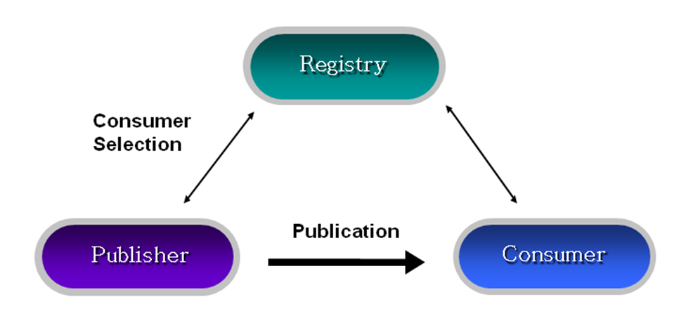

(Figure 1) Basic pattern 1

- Basic pattern 2 –In this second pattern, the consumer filters messages based on publisher’s properties. They request to the INFOD registry to find publishers.
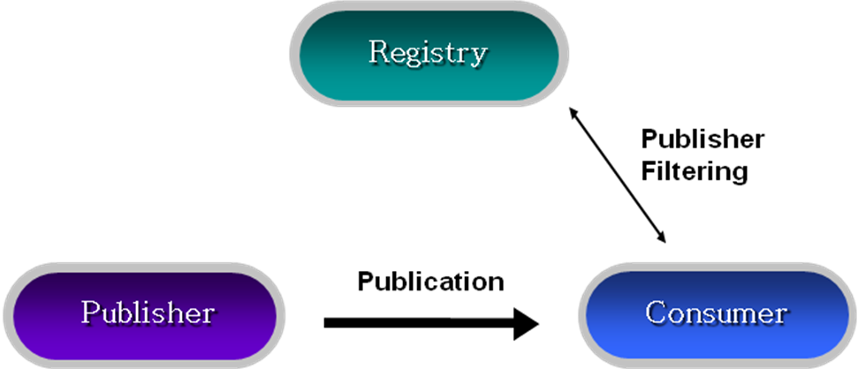

(Figure 2) Basic pattern 2
- Single Disseminator –This pattern includes a disseminator to the pattern 1 and 2. In the pattern 3, a disseminator provides sending events to a number of consumers. The disseminator matches the subscriptions of consumers to information of publishers and sends the messages to the selected consumers.

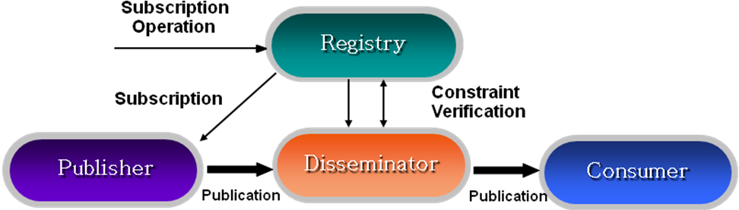

(Figure 3) Single Disseminator

Our experiment targets pattern 3. In the architecture, five entities - sensors or Application specific service as publisher, doctors as consumers, subscriber, registry, and disseminator – are modeled. This will be discussed in detail at section 3.

ARROW Architecture

Overview of ARROW

Our architecture has two parts as processing part and disseminating part. We propose our overall system called ARROW (Adaptive and Reconfigurable ResOurce Management for Wireless sensors using grid technology) which consists of “Interface & Processing” and “Information Disseminator”. We will present them in detail of section 3.2 and section 3.3 as shown in figure 4.

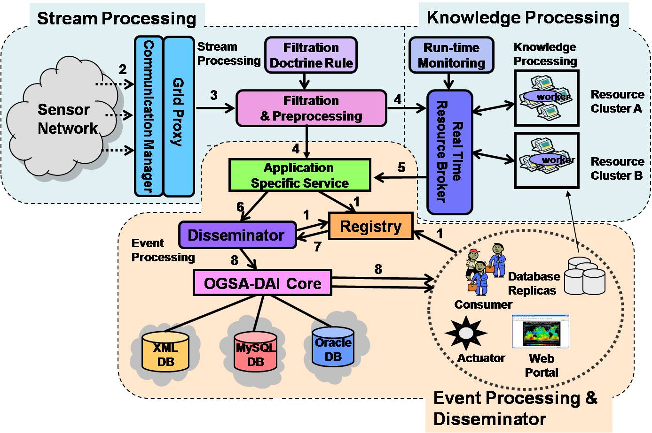
(Figure 4) The ARROW architecture

Interface & Processing

Interface & Processing Architecture

The Interface & Processing is designed for collaboration with sensor network and Grid. The raw data can be processed and filtered using Grid resources in this architecture. The Interface & Processing has three components. The definition of each component of the Interface & Processing is explained as follows:

- Communication Manager (CM) –It communicates to the wireless sensor devices or wireless sensor gateway. It works as a bridge between wireless entities and mitigates the effect of frequent network disconnection, security and fault recovery. CM also employs important algorithm to retrieve data from wireless sensor devices. After collecting the data from the sensor devices, CM sends it to the Filter Manager (FM).
- Filter Manager (FM) –FM collects the sensor data and requests for resources to RM (Resource Manager) to aggregate the sensor data and to filter the data using event doctrine file which the administrator defined.
- Resource Manager (RM) – RM seamlessly serves dispersed Grid resources to FM for filtering sensor data. RM monitors the resource workload to adapt the variations in the resource performance and application requirements.

This system flow as shown in figure 5 is explained step by step as follows;

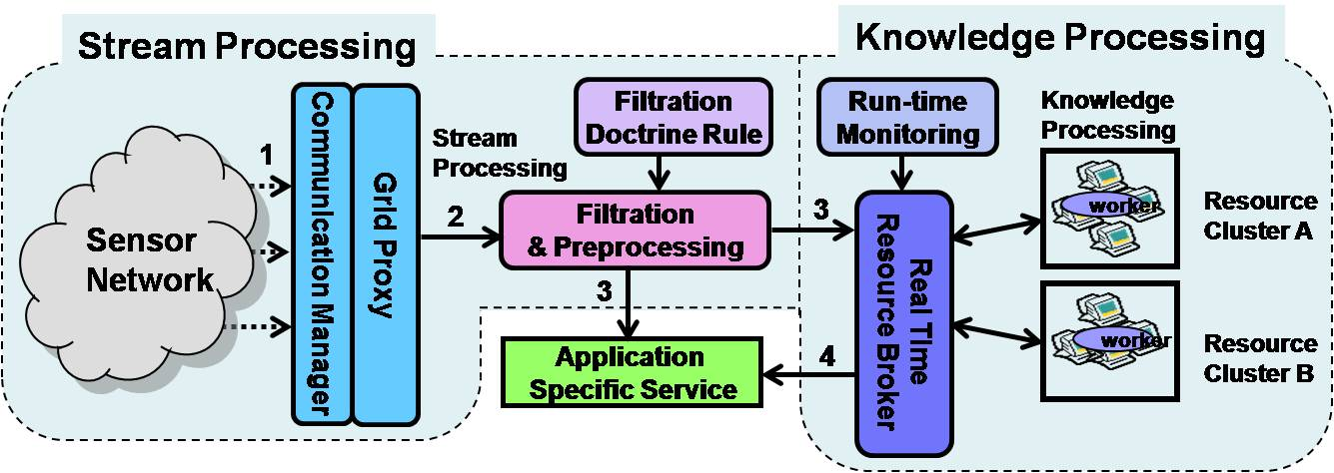
(Figure 5) Architecture of processing interface

Step 1: Sensors sense data from the environment.
Step 2: CM gathers the data and propagates to FM for pre-process and low level filtration.
Step 3: FM collects the sensor data and requests for resources to RB (Resource Broker) and application specific service. RB aggregates the sensor data and filters the data using event doctrine file which administrator defined.
Step 4: RM sends to Application Specific Service to disseminate the data to users using Information Disseminator.

Information Dissemination Architecture

As we mentioned in section 1, Info-D standard is well explained in [12] by illustrating use cases; NextGRID Graphical Animations use case, car dealer use case, and Sensor Networks use case. Our implementation considering Grid environments need to plug the Data Grid technology. OGSA-DAI, widely used tool, is employed and discussed in following subsection.

OGSA-DAI

OGSA-DAI [13] handles data resources, such as flat file, relational or XML-databases, to be accessed via stateful web services. It also allows data to be queried, updated, transformed, and delivered. More detail advantages of OGSA-DAI is indicated as follows;

- We don’t need additional code to connect to a data base or querying a data. OGSA-DAI support an interface integrating various databases such as XML databases and relational databases.
- The OGSA-DAI provides three basic activities that are querying a data, transforming a data, delivering the results in sequence. The OGSA-DAI can support not only querying and transforming but also delivering using ftp, e-mail, and push services.
- OGSA-DAI allows users to make new activities they want. This function is very scalable and powerful to use the data resource in various ways.

It is clear taking advantages of OGSA-DAI for information dissemination in Grid environment

Information Disseminator System Flow

Following is the information disseminator system components as showing in the figure 6 ;

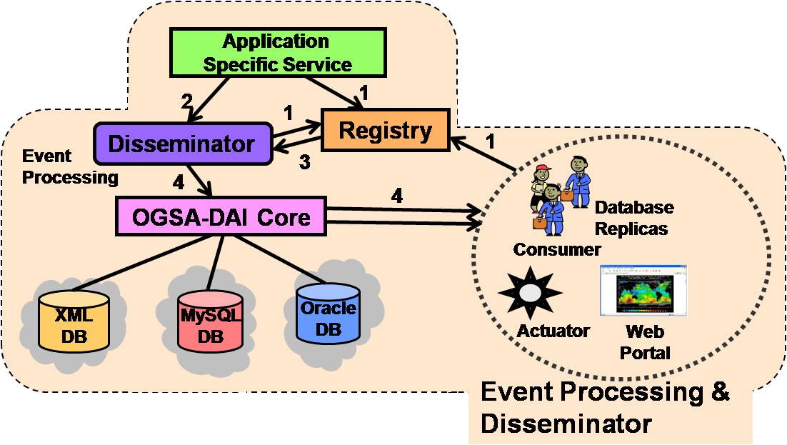
(Figure 6) Information disseminator components

Step 1: Each entity should register its information to the registry.
Step 2: Application specific service sends the processed data to the disseminator.
Step 3: Registry can manage, store subscription of each entities and distribute the information to disseminator(s). Disseminator can distribute sensor data to users efficiently using the information
Step 4: Disseminator detects event data for immediately delivery and schedules time based data for regular delivery according to the consumer’s subscriptions. It also stores sensor data to heterogeneous and distributed resources in amount of uniform access using OGSA-DAI.
The figure 7 explains detail steps for the Information Dissemination system.

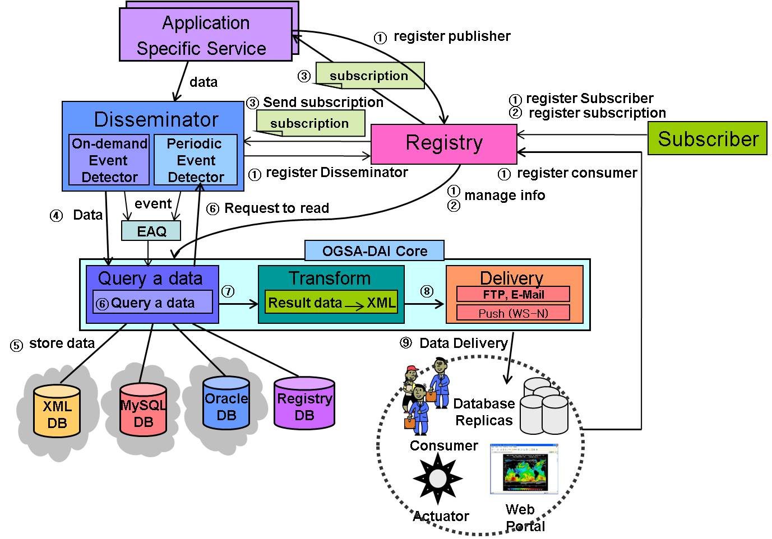
(Figure 7) The Information dissemination system flow

➀ Components of the information dissemination system (such as Application Specific Service, consumers, disseminator) register their information to the registry.
➁ Consumer send the subscriptions which include consumer’s interests to the registry using subscribers. Registry stores the information to the OGSA-DAI.
➂ Registry sends subscriptions to disseminator.
➃ When sensor data reaches to the system from “Application Specific Service”, disseminator detects whether the sensor data is an event data or not. In our model, the subscription allows predicate to have single condition or multiple conditions. If the predicates include single condition the system processes step ➄ and step ➆ directly. If the predicates include multiple conditions, the event is sent to the EAQ(Event Aggregation Queue) that aggregates multiple events to make an event(i.e. doctors may want to see patient’s status when blood pressure is abnormal and heartbeat rate is high at the same period as well.)
➄ Before disseminating sensor data to consumers, disseminator stores sensor data to storage.
➅ When a predicate includes single condition, Periodic Event Detector schedules dissemination using subscriptions, and requests queries to the OGSA-DAI. In case of the predicate with multiple conditions, if enough events are stored in EAQ, the disseminator disseminates the data to ➄& ➆ steps.
➆ The disseminator requests to transfer the data to XML format using perform document.
➇ OGSA-DAI delivers the data to various consumers using FTP, E-mail or Web services Notification(WS-N) protocols.

Matching algorithm for Information Disseminator

Several researchers proposed event matching algorithms for pub/sub(publish/subscribe) to find event using matching mechanism. In the algorithm [14], authors propose a scheme using tree structure of predicates. They construct a tree and match data by traversing from root(attr1) to sub-nodes(attr2, attr3..) as shown in the figure 8. In the figure, ‘*’ represents a matching condition that means all values are acceptable. When the data reaches the last node, the target subscriptions eventually are matched. The figure 9 shows an example using data=<1,2,3,8,2> with the matching algorithm. The subscription ‘I’<1,2,3,*,2> exactly matches to the data and becomes an event to the subscriber.
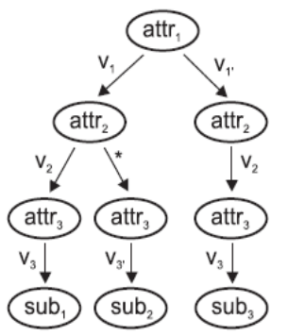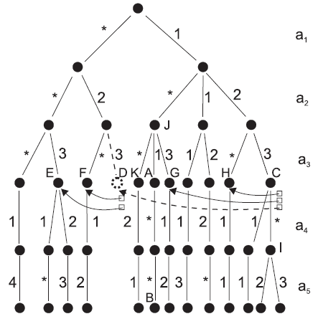
(Figure 8) Subscription tree (Figure 9) Predicates construction

The algorithm in [15] triggers events using semantic mechanism in the EAI (Enterprise Application Integration). Figure 10 shows creating events as “on-to-one”, “one-to-many”, “many-to-one”, and “many-to-many”.

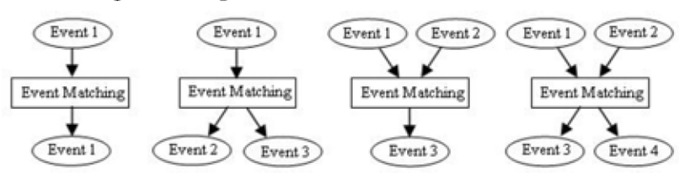
(Figure 10) Patterns of information matching in EAI

After triggering new events, COBDD (Colored Order Binary Decision Diagram) represents their matching procedure as shown in figure 11. Figure 12 shows matching algorithm using OBDD(Order Binary Decision Diagram) for instance x∨(y∧z). The COBDD can be extended to OBDD as shown in the figure 11. They separates x∨(y∧z) into two predicates, C(x)∨O((y∧z)). Predicate C and O are different so that they can be combined to one by using COBDD. It results in 0(not matched) or 1 (matched).

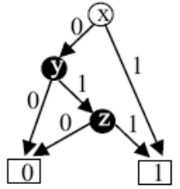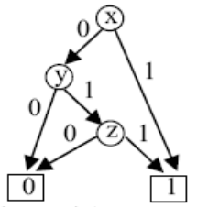
(Figure 11) x∨(y∧z) (Figure 12) C(x)∨O((y∧z))

Another algorithm in [16] uses group of predicates to reduce matching time assuming that subscriptions may have many identical predicates. The proposed scheme reduces resources consumption and matching time efficiently, while redundant sequential matching wastes computational resources. As shown in figure 13, grouped index of predicates is used to search subscriptions joining predicate id and subscription id.
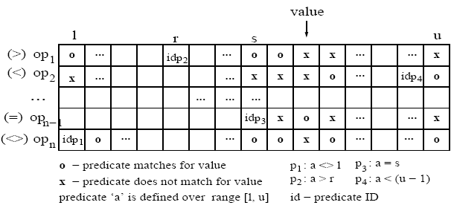
(Figure 13) Grouped index of predicates

The forwarding algorithm in [17-18] provides an efficient mechanism which matches corresponded predicates using attribute Indexing and Grouping as shown in the figure 14. Each predicates can include multiple attribute. The algorithm groups the predicates using attributes and operators of predicates, and the values of predicates are aligned into columns. The figure 15 shows the indexed attribute and architecture of the algorithm in detail. If sensor data matches with attribute “Quantity”, then it matches operators. After choosing an operator, it matches values of predicates sequentially.

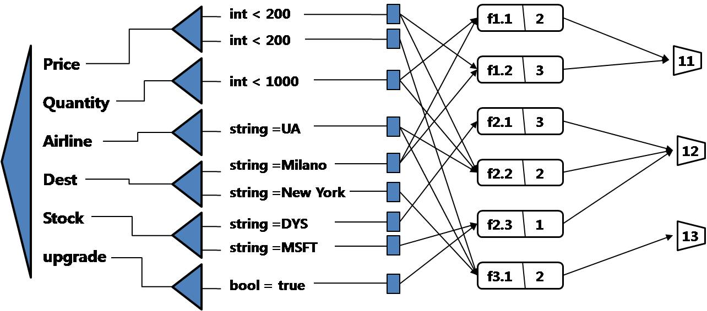

(Figure 14) Forwarding algorithm

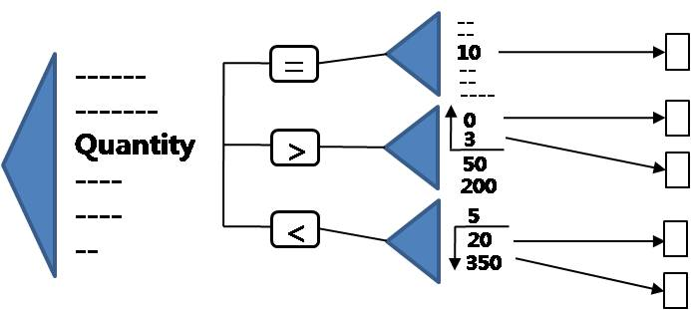
(Figure 15) Example of integer constraint Indexing

These algorithms result a value, when the predicate of subscription matches to a specific constant. This condition can be resolved simply using tree based sequential matching as solved in [17-19]. However, if predicate’s condition requires certain range like u-Health sensor event processing system that consumers (doctors and nurses) express their interests into a range, then the problem become harder and difficult to apply above techniques to trigger events. As patient states are changed continuously within certain range(min, max) like body temperature and heartbeat, each classified consumer will require events in various range to take care patients safely. So, ranged predicates are more efficient to describe consumer’s interests. Furthermore, the ranged predicate has several conditions as equivalence, subset, or intersection as shown in figure 16. In order to match efficiently to this situation, we propose a novel scheme called “Classed Group Index Matching (CGIM)”.

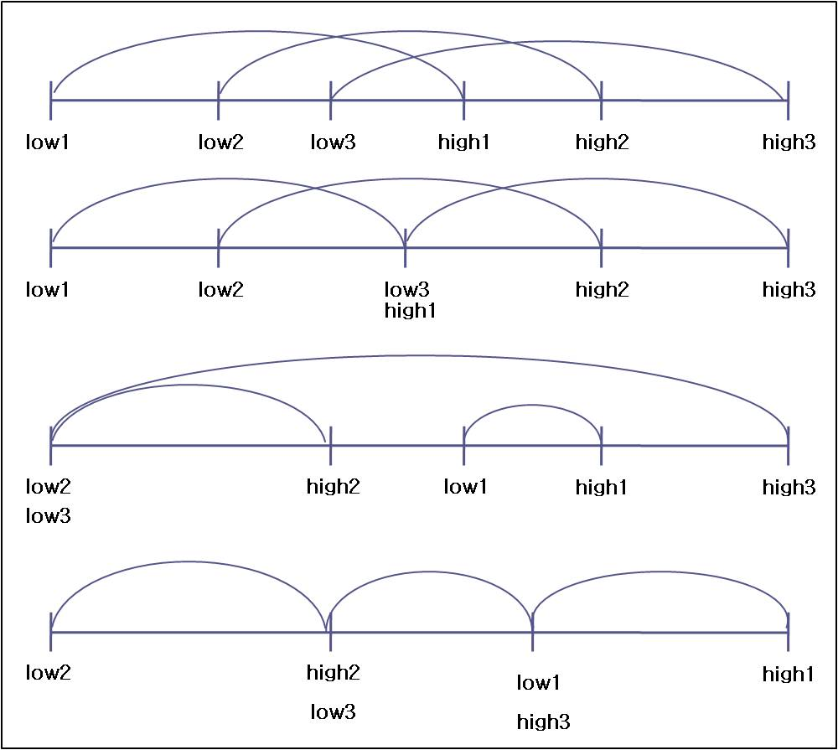

(Figure 16) Ranged predicates on u-Health event processing system

The specific feature challenges of the proposed system are as follows:
1) The information dissemination (denoted to Info-D) system should send sensor event messages to consumers directly on triggering and deliver them every period subscribed.
2) The Info-D system should support several types of data such as blood pressure, temperature, pulse, or electrocardiogram in u-Health environment.
3) The Info-D system should allow subscribers to describe two ranged predicates, (low_threshold_value< observed_data < high_threshold_value) and (low_threshold_value>= observed_data, high_threshold_value=<observed_data)
4) The Info-D system need to process efficiently to handle a number of subscriptions of various consumers.

Event detection model

We designed the event detection model showing detection of event is triggered by period or on time using BDD(Binary Decision Diagram). Sensor data include not only simple sensed value but also a department of hospital such as Circulatory organ, Digestive organ, Respiratory organ, and kidney organ (denoted to p, q, r, s, respectively) and event type such as blood pressure, temperature, blood pressure (denoted to t, u, v, respectively shown in figure 18). In the figure 17 showing our BDD model, there are four types of node to find which data belongs to the range of predicates. Node x represent a minimum threshold value of the range and node y for maximum threshold value of the range in a predicate of the subscription. Event triggering, which is shown in the figure 17, needs to match a sensed data to all predicates of subscriptions. This causes complexity on matching in the time and space domain, so we need an efficient matching algorithm considering various types of subscriptions requested by many subscribers such as nurses, staffs, and doctors. Therefore, next sections, 4.2 and 4.3, introduce our effort to design of an efficient matching algorithm for pub/sub systems.

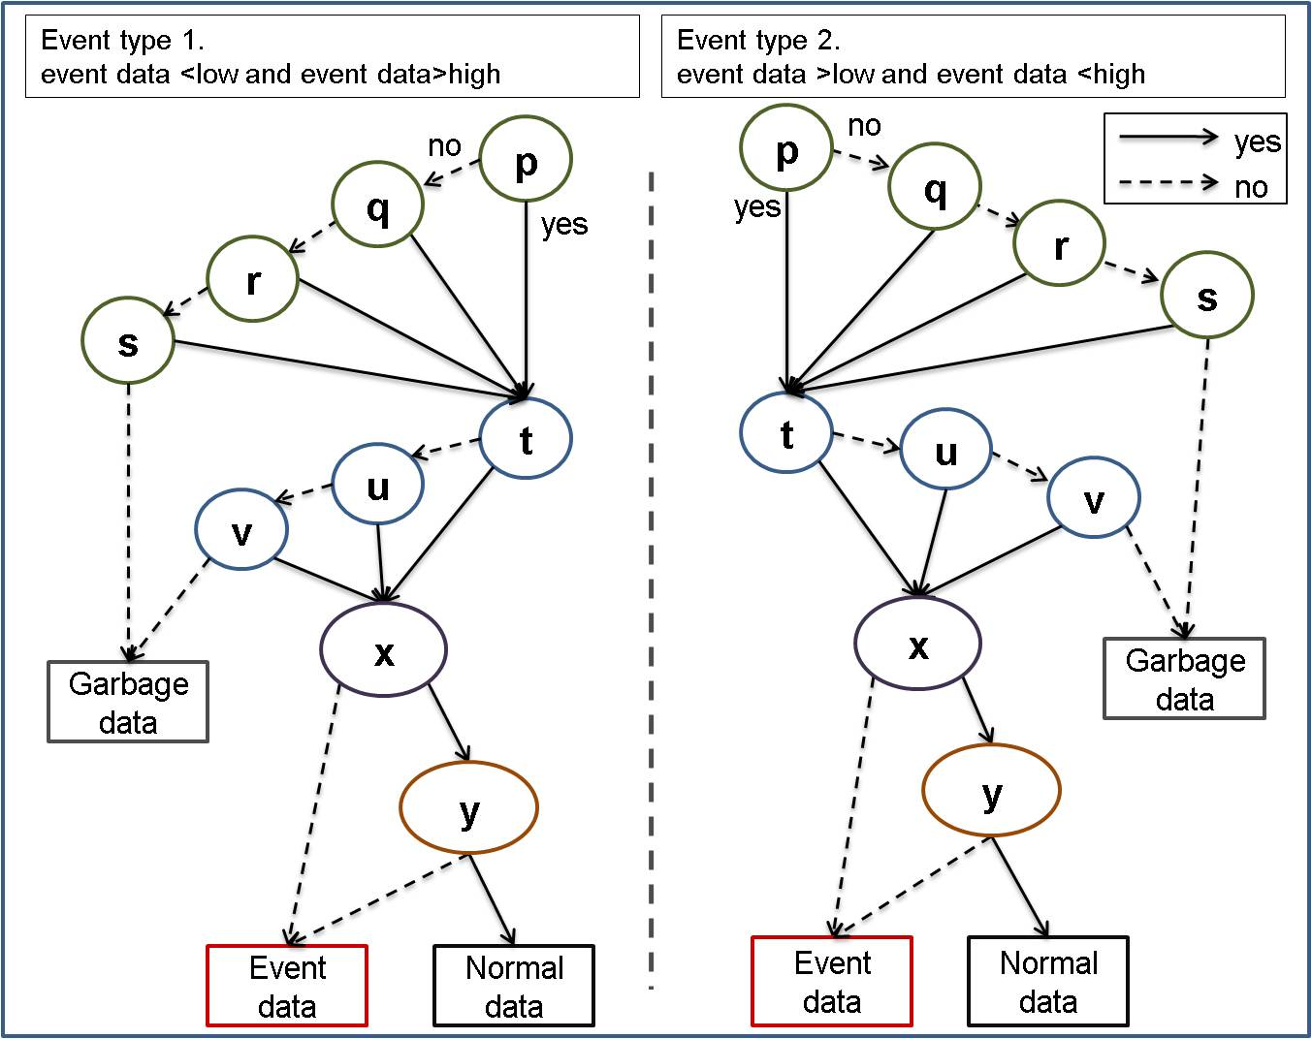
(Figure 17) Simple matching BDD model

The grouping of predicates

Subscriptions are composed of consumer’s personal information and predicates which show consumer’s requirement. Each predicate, P, constructs of five elements such as P={event_type, N, op, mPV, MPV}, where the ‘event_type’ for detail event name, ‘N’ for the count of predicates,(i.e. ‘1’ for single data matching with mPV and MPV, and ‘2’ for two sensed input data to match mPV and MPV at the same time. The ‘op’ represents an operation such as “<<”, or “<>”. Also, mPV and MPV stand for minimal threshold value of the predicate and maximum threshold value of the predicate, respectively. The Information Dissemination system in the ARROW supports various expressions of predicates. First, “(mPV< data < MPV)” is used when consumers want to know normal patterns of sensed data as shown in the figure 18-(a). Second, “(mPV>data || MPV<data)” is used when consumers need to receive unusual states of the patient as shown in the figure 18-(b). Third, “(mPV> data1 && MPV<data2)” is used to support for two outputs of a sensor such as blood pressure as shown in the figure 18-(c).

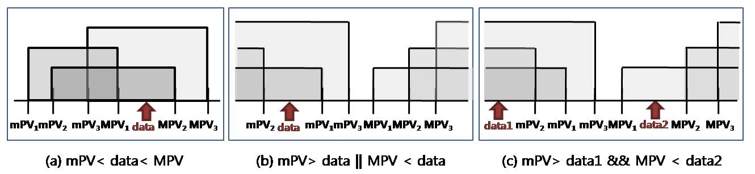
(Figure 18) Expression case of CGIM

As we discussed in section 4.1, a data which should be delivered on time will be matched to all predicates of subscriptions exactly. We employed the grouping scheme to reduce overhead in matching as shown in the figure 19. First we grouped all minimal threshold value of predicates from all subscription denoted to mS for the set of mPVs, i.e. mS={mPV₁,mPV₂…..mPV_{i}} and MS for the set of MPVs, i.e. MS={MPV_{1,}MPV₂....MPV_{i}}. The figure 20 describes grouping technique of predicates in detail.

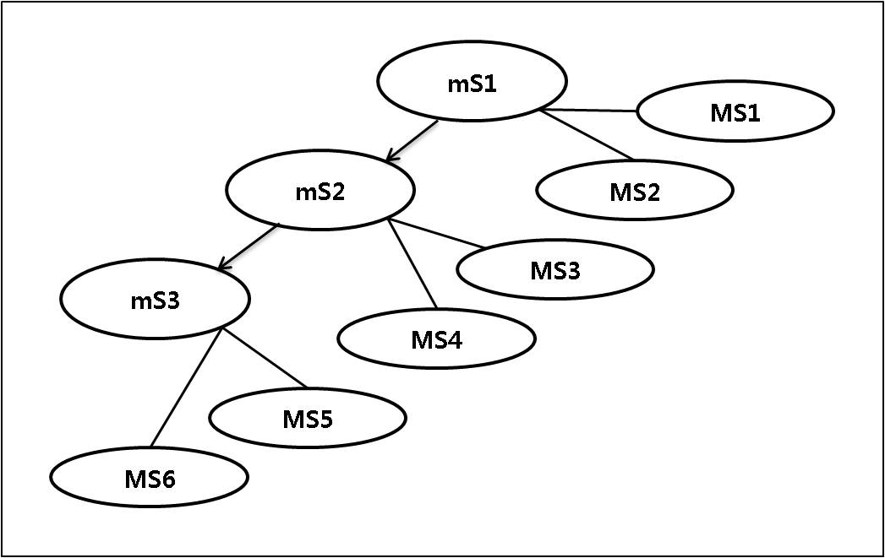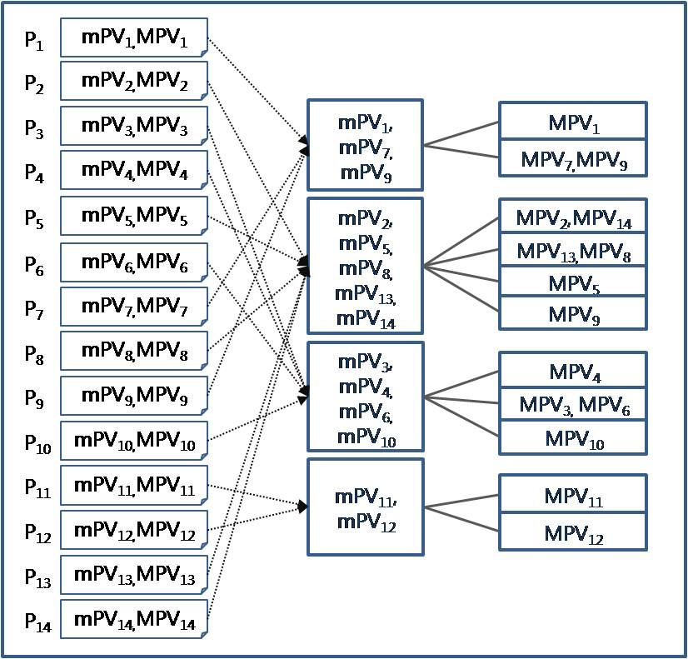
(Figure 19) Grouping tree (Figure 20) Grouping predicates

CGIM (Classed Group Index Matching) algorithm

In this section, we explain the procedure of our matching algorithm with the figure 21. First, coarse level grouping partitions mS and MS among all subscriptions into small groups explained in section 4.2, which is done at the system initialization. Second, dynamic fine level grouping compares sensed data to maximum mPV. If matches, then comparison with MS within same predicate’s ID as mS is tested. This step produces feasible candidates, which is not enough to be the final predicate, as each ranged predicate can not be matched to the set, mS and MS. So, third, exact matching step is required to compare data with each predicate in selected predicate groups. Finally, the algorithm finds subscriptions by joining selected predicate id(s) and subscription id(s). The detail CGIM for grouping technique is introduced in subsection 5.2.1 titled dynamic re-grouping approach.

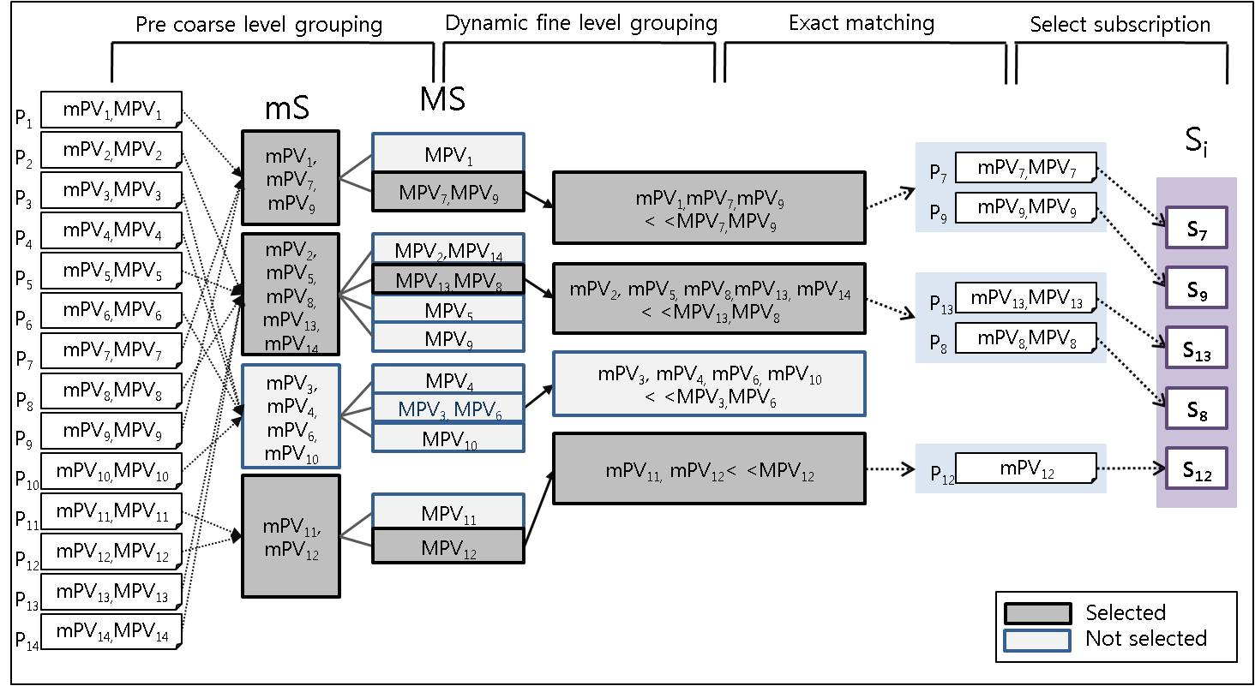
(Figure 21) CGIM procedure of matching algorithm

Performance evaluation
In this section, we examined our CGIM algorithm on u-Health care system with various scenarios. As the range of the human body conditions has limitation, consumer’s interest (expressed in subscription) is also within reasonable boundary. The figure 22 shows subscription’s distribution of body temperature submitted by nurses, staffs and doctors.

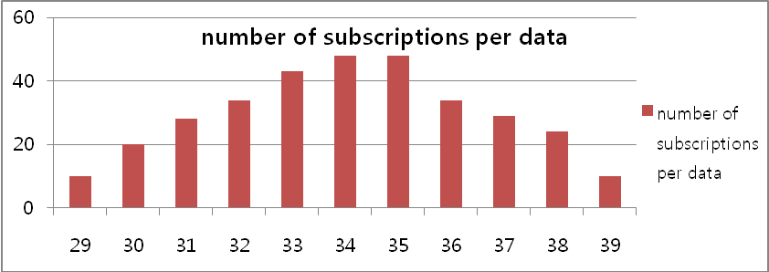
(Figure 22) The numbers of subscriptions per data

5.1. Performance comparison

The basic partitioning idea from statistics is employed to decide the number of class for mS and MS (denoted to m and M, respectively) by m=1+log₂ n(mS), and M=log₂ n(MS), where n(mS) is the number of element in the set, mS. The statistical grouping (denoted to SG) method decides an equivalent interval of each class by (y-x)/m and (Y-X/M) for mS and MS, respectively. Figure 23 shows the detail of partitioning method in (a) and distribution of groups in (b).

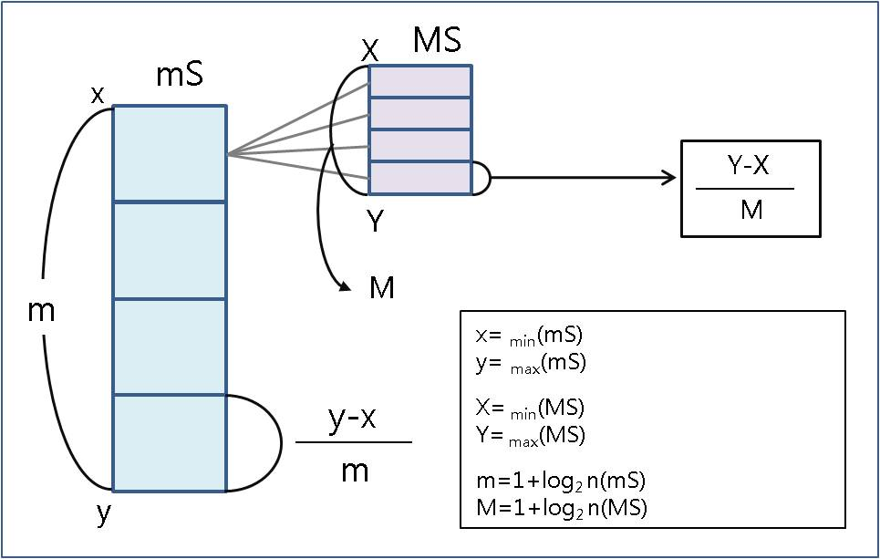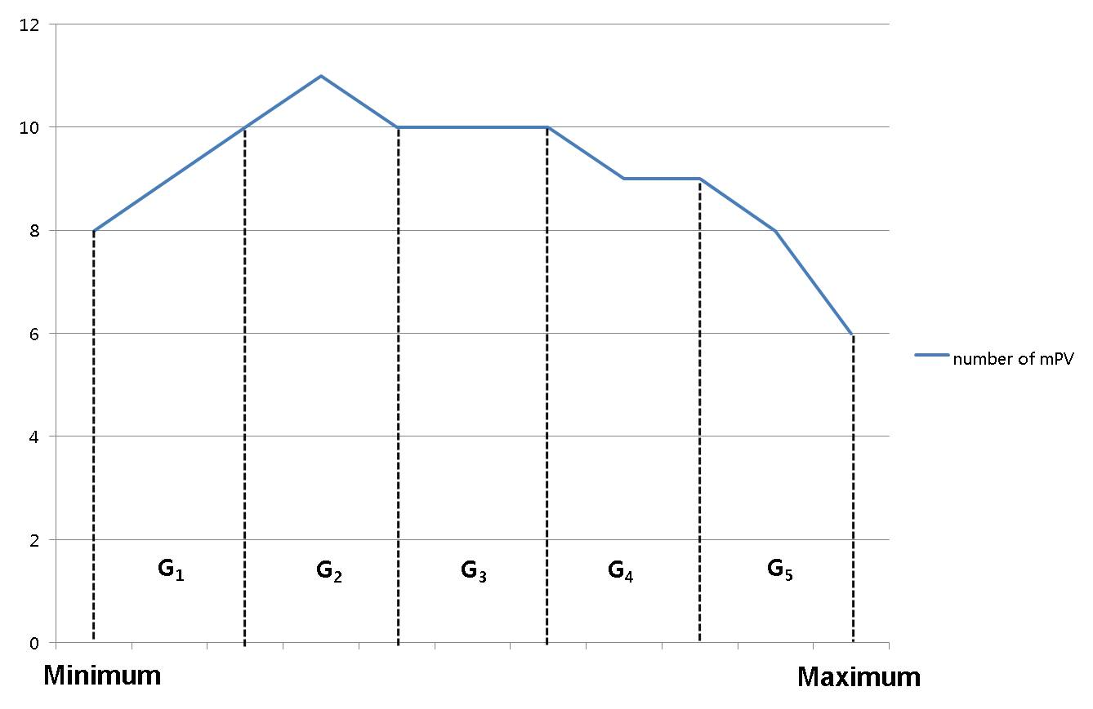
(a) grouping method (b) distribution of groups

(Figure 23) Conventional statistical fixed interval partitioning

The pub/sub system needs to handle various cases of predicate expressions for diversity of subscribers. As we mentioned, three different cases are employed in CGIM. In following experiments, we conduct performance comparison with three previous algorithms. The algorithms are described as follows;

(1) Worst case (Sequential matching): If sensor data reaches to the system, Sequential matching matches all subscription with the data sequentially.
(2) Forwarding algorithm: Forwarding algorithm matches data to subscriptions which include a single predicate. It groups predicates using attributes and operators, and indexes the values of predicates. This algorithm results two groups of predicates by matching two operators and finds correct predicates by combination the two results
(3) Best case(Optimal matching): it matches data with subscriptions optimally.

As we mentioned, three different predicate cases are examined to the above schemes. The experiment for each case is explained as follows.

- Case 1: mPV < data < MPV
The following experiment shows the total comparison using three algorithms and CGIM. The figure 24 shows the matching comparison of the CGIM algorithm with different numbers of groups and three algorithms with five sensed data for the predicate case 1. The worst case and the forwarding algorithm match “minimal value<data” and “maximum value>data” separately using indexing predicates and combines the results. The matching comparison is computed by 1000 for the worst case and 646 for the forwarding algorithm, while the proposed CGIM requires only 273 matches totally.

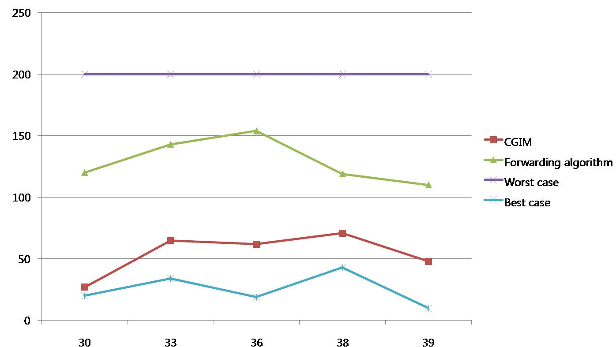

(Figure 24) Matching for the predicate case 1

So the additional comparison is calculated by 874 for the worst case, 520 for the forwarding algorithm, and 147 for the CGIM (where additional matching time = each algorithm matching comparison - best case matching comparison). Thus, the CGIM can reduce 83% and 71% wasted matching time than the worst case and the forwarding algorithm, respectively.

- Case 2: mPV>data || MPV<data
This experiment is done for the predicate case 2 under the same condition as the predicate case 1. The figure 25 shows the matching comparison of the CGIM algorithm with different numbers of groups and three algorithms. The comparison is computed by 1000 for the worst case, and 284 for the forwarding algorithm. The proposed CGIM requires 446 matches on average. In this case, the forwarding algorithm performs better than the CGIM algorithm. But, it requires more space for indexing all predicate values, while CGIM makes index for groups. If we index all sub-predicates, equivalent performance will be measured.

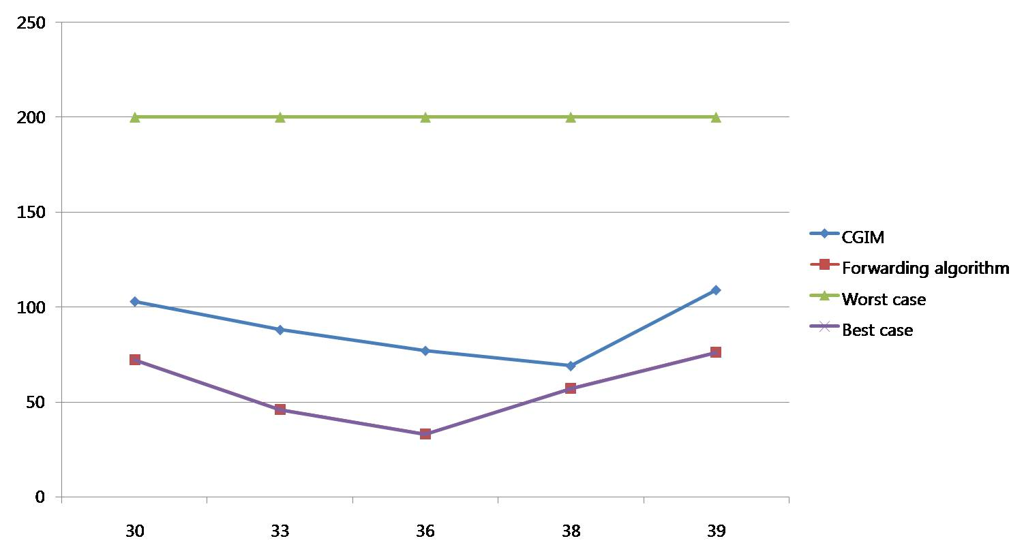
(Figure 25) Matching for the predicate case 2

- Case 3 : mPV>data1 && MPV<data2
This experiment is designed for multiple event matching with two sensed inputs. In this experiment, we measured the total matches with four pairs of subscriptions such as (mPV=29>data1, MPV=38<data2), (mPV=29>data1, MPV=33<data2), (mPV=33>data1,MPV=37<data2), and (mPV=32>data1,MPV=35<data2). As shown in the figure 26, the matching comparison is counted by 1000 for the worst case and 364 for the forwarding algorithm, while the proposed CGIM requires only 197 matches on average. The CGIM can reduce 80% and 46% wasted matching comparison than the worst case and the forwarding algorithm, respectively.

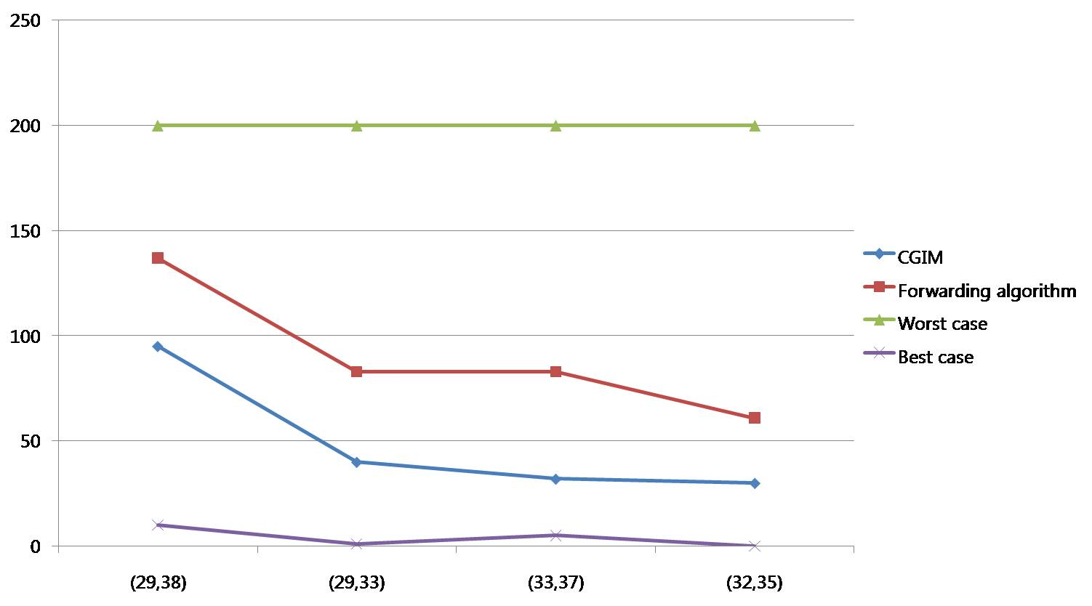
(Figure 26) Matching for the predicate case 3

5.2. Impact of grouping

As seen from the above experiments, statistical based CGIM performs better than previous works especially for case 1&3. However, different statistical distribution of subscriptions may result in different matching performance. In this section, we analyze statistical metrics of subscription distribution with various types of predicates and suggest two efficient grouping methods.
For different grouping techniques for case 1, we examined 50 subscriptions for 3 sensed data (data=30, data=36, data=38) with statistical group and various number of groups, and CGIM is executed. The figure 27 shows the result of our examination.

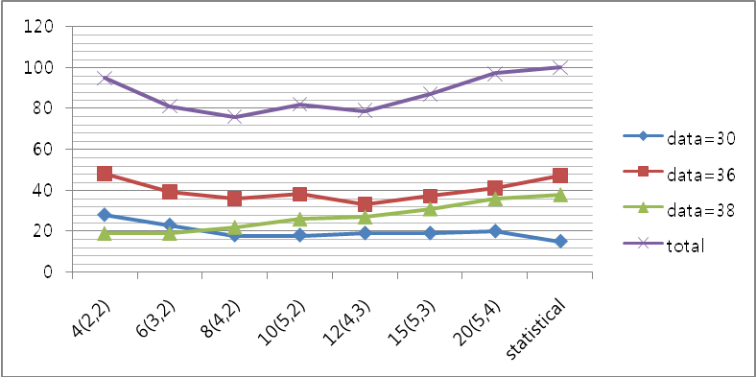
(Figure 27) Event triggering with various number of classes

From the figure 27, we found that CGIM performs well and different number of classed groups affects matching performance. The x axis in figure 27 shows the different number of classed groups. So the “10(5,2)” indicates 5 predicates in each mS set, 2 predicates in each MS set, and 10 means total number of groups. In here statistical approach, 7 predicates are equally assigned to each class.
According to the figure 27, searching time also depends on 2 factors: input data and the number of groups. If sensed data is very low or high value, the matching will go through to the end of group by traversing tree as shown in BDD model. Also, the number of predicates in a class affects comparison time.

5.2.1 Statistical approach to Dynamic Re-Grouping (DRG)
As shown from the figure 27, it is important to decide proper number of groups to improve performance. In this section, we analyzed characteristics of subscription’s distribution, and then found that more centralized mS and MS distributions to mode (most frequently appeared sample) need sub-divided groups with different interval size, while traditional approach uses equivalent interval for all the samples. Thus, depending on kurtosis, the number of classed groups is analyzed as follows.

According to kurtosis, as shown in the figure 28, it divides whole range to three groups. The range of the first group is bigger than minimum value of subscription and smaller than α. The second groups’ range is bigger than α and smaller than β, and the range of the rest is bigger than β and smaller than the maximum value of mS or MS. After that, the second group divided to subgroups, and the number of groups (i.e. G2, G3, G4) is calculated by statistical method shown in the figure 23. For the re-grouping, statistical metrics are considered as follows:
α= Mode - Standard deviation
β= Mode + Standard deviation

The figure 28 shows how dynamic re-grouping is produced in our scheme.

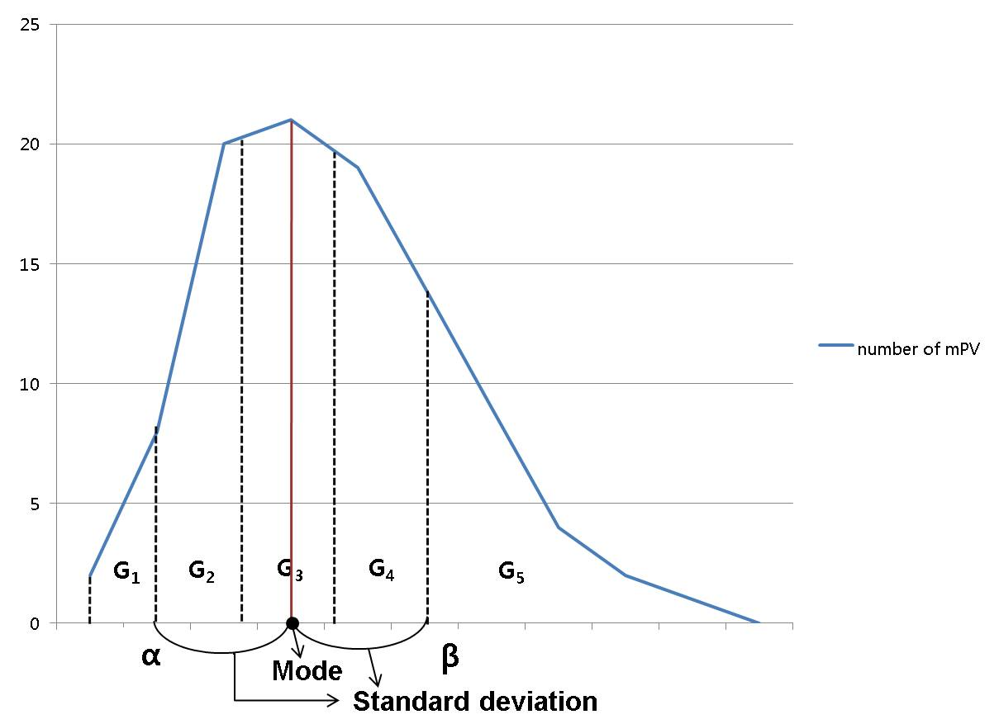
(Figure 28) Dynamic re-grouping approach
The fixed interval for groups is efficient on low kurtosis. This might be useful for subscriptions distributed uniformly. The DRG method is efficient when kurtosis of subscription distribution is high. In order to verify the efficiency of dynamic re-grouping rather than the conventional SG approach, we compared them with same number of groups in case of a specific subscription with normal distribution.

(Table 1) DRG matching performance

group numbers | 29 | 31 | 32 | 33 | 35 | Total performance
4 | 10 | 26 | 81 | 81 | 104 | 302
5 | 10 | 26 | 57 | 82 | 105 | 280
6 | 10 | 27 | 58 | 83 | 106 | 284
Best_case | 3 | 26 | 53 | 77 | 98 | 257

(Table 2) SG matching performance

group numbers | 29 | 31 | 32 | 33 | 35 | Total  performance
4 | 26 | 26 | 80 | 80 | 100 | 312
5 | 10 | 56 | 56 | 93 | 103 | 318
6 | 10 | 56 | 56 | 93 | 101 | 316
Best_case | 3 | 26 | 53 | 77 | 98 | 257

From table 1&2, the group with different intervals in DRG performs better than groups with equivalent interval in SG, even though same number of groups is applied. Overall average matching comparison from the table 1&2 is computed by 315 for the SG and 288 for the DRG.

According to the result of the table 1&2, we simulated additionally to find how much the DRG is more efficient than the SG with various distribution types of subscriptions. The types of subscriptions are classified by kurtosis. The examples of subscription patterns are described in the table 3.

(Table 3) The example of the subscription distribution pattern

Subscription Type | Type 1 | Type 2 | Type 3 | Type 4 | Type 5
Kurtosis | 2 | 2.5 | 3 | 3.5 | 4
Skewness | 0.232812 | 0.406678 | 0.1255 | 0.642479 | 0.490915
Standard deviation | 2.989865 | 2.557046 | 1.489221 | 1.5 | 1.623191
variance | 8.939293 | 6.538485 | 2.217778 | 2.25 | 2.634747
Average | 32.51 | 31.87 | 31.38 | 31.25 | 31.54
Mode | 31 | 31 | 31 | 31 | 31

We calculated efficiency of the DRG by comparing the SG performance as shown in the table 4. The numbers in column of table 4 means over-performed number of comparison from the optimal (best) case.

(Table 4) The efficiency of the DRG

Subscription Type | Type 1 | Type 2 | Type 3 | Type 4 | Type 5
DRG overhead | 16 | 4 | 4 | 5 | 4
SG overhead | 48 | 22 | 24 | 58 | 31
Compared DRG efficiency | 66.70% | 81.90% | 83.40% | 91.40% | 87.10%

5.2.2 Performance Prediction

Various subscription’s distributions by many different users will deliver different performance. In this subsection, we illustrate efficiency prediction on various subscriptions using DRG. From the previous results shaded (kurtosis, efficiency) in table 5, we derived the formula of the efficiency by using linear regression to estimate efficiency as shown in the table 5 and the figure 29.

(Table 5) Estimation of efficiency

Kurtosis | efficiency (%)
0 | 51.92
0.5 | 56.95
1 | 61.98
1.5 | 67.01
2 | 66.7
2.5 | 81.9
3 | 83.4
3.5 | 91.4
4 | 87.1
4.5 | 97.19
5 | 98.482

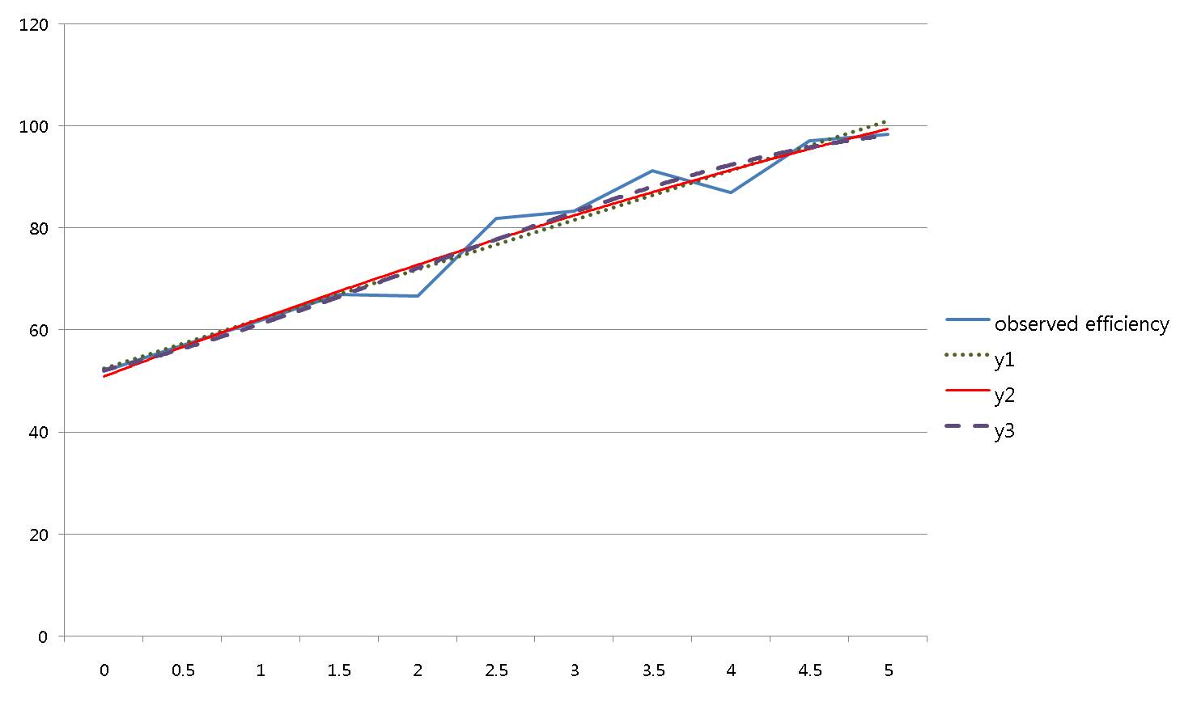
(Figure 29) The observed efficiency and trend lines
We examined three formulas to find more accurate estimation as shown in figure 29. The first formula employing one dimensional linear equation, y1 = 4.860x + 47.57, brings 96% accuracy. The second formula employing quadratic equation, y2 = -0.103x² + 6.098x + 44.88, corresponds 97% accuracy. The third formula applying cubic equation, y3 = -0.037x³ + 0.568x² + 2.734x + 48.95, corresponds 96% accuracy.

Conclusion
In this document we have proposed the ARROW architecture which integrates sensor network and Grid for information dissemination. The ARROW supports a gateway between sensor network and Grid to process, manage huge amount of data, provide interfaces for consumers, and employs the pub/sub system. An efficient matching algorithm called CGIM considering three types of predicates reduces matching overhead significantly. As we conducted many experiments, the following contributions are summarized:
1) Provision of time and event driven delivery
2) Allowing multiple event data generation with ranged predicates
3) Flexible expression for diverse consumers
4) Efficient dynamic re-grouping based on statistical distribution of subscription
5) Prediction of matching efficiency using DRG

Author Information
Eui-Nam Huh
Kyung Hee University
Korea
Johnhuh@khu.ac.kr

Bo-Hyun Seok
Kyung Hee University
Korea
bohyun@icns.khu.ac.kr

Intellectual Property Statement

The OGF takes no position regarding the validity or scope of any intellectual property or other rights that might be claimed to pertain to the implementation or use of the technology described in this document or the extent to which any license under such rights might or might not be available; neither does it represent that it has made any effort to identify any such rights. Copies of claims of rights made available for publication and any assurances of licenses to be made available, or the result of an attempt made to obtain a general license or permission for the use of such proprietary rights by implementers or users of this specification can be obtained from the GGF Secretariat.

The GGF invites any interested party to bring to its attention any copyrights, patents or patent applications, or other proprietary rights which may cover technology that may be required to practice this recommendation. Please address the information to the GGF Executive Director.

Full Copyright Notice

Copyright (C) Global Grid Forum (2007). All Rights Reserved.

This document and translations of it may be copied and furnished to others, and derivative works that comment on or otherwise explain it or assist in its implementation may be prepared, copied, published and distributed, in whole or in part, without restriction of any kind, provided that the above copyright notice and this paragraph are included on all such copies and derivative works. However, this document itself may not be modified in any way, such as by removing the copyright notice or references to the GGF or other organizations, except as needed for the purpose of developing Grid Recommendations in which case the procedures for copyrights defined in the GGF Document process must be followed, or as required to translate it into languages other than English.

The limited permissions granted above are perpetual and will not be revoked by the GGF or its successors or assigns.

This document and the information contained herein is provided on an "AS IS" basis and THE GLOBAL GRID FORUM DISCLAIMS ALL WARRANTIES, EXPRESS OR IMPLIED, INCLUDING BUT NOT LIMITED TO ANY WARRANTY THAT THE USE OF THE INFORMATION HEREIN WILL NOT INFRINGE ANY RIGHTS OR ANY IMPLIED WARRANTIES OF MERCHANTABILITY OR FITNESS FOR A PARTICULAR PURPOSE."

This document and the information contained herein is provided on an “As Is” basis and the OGF disclaims all warranties, express or implied, including but not limited to any warranty that the use of the information herein will not infringe any rights or any implied warranties of merchantability or fitness for a particular purpose.

References
1. Salman AlSairafi et al. Michelle Osmond, Anthony Rowe, Jameel Syed, Patrick Wendel, “THE DESIGN OF DISCOVERY NET: TOWARDS OPEN GRID SERVICES FOR KNOWLEDGE DISCOVERY”, The International Journal of High Performance Computing Applications, Volume 17, No. 3, Fall 2003, pp. 297–315

2. R. Bramley et al. "Instruments and sensors as network services: Making instruments first class members of the grid". Technical Report 588, Indiana University CS Department, December 2003.

3. Hock Beng Lim, et al. "Sensor Grid: Integration of Wireless Sensor Networks and the Grid", Proceedings of the IEEE Conference on Local Computer Networks 30th Anniversary (LCN’05)

4. Chen-Khong Tham et al, "SensorGrid: Integrating Sensor Networks and Grid Computing", CSI Communications, pages 24-29, Vol.29, No.1, ISSN 0970-647X, Computer Society of India (CSI), Mumbai, India, July 2005.

5. Zubair A. Baig et al, "SGSIA-In-Network Data Preprocessing for Secure Grid-Sensor Integration", Proceedings of the Second IEEE International Conference on e-Science and Grid Computing (e-Science'06)

6. Gero Mühl et al, ” Disseminating Information to Mobile Clients Using Publish–Subscribe”, Vol. 8 ,46-53, 2004, ISSN:1089-7801,IEEE Internet Computing

7. Ioana Stanoi et al, “A Framework for the Selective Dissemination of XML Documents based on Inferred User Profiles”, Proceedings of the 19th International Conference on Data Engineering (ICDE’03)

8. Open Grid forum, “http://www.ogf.org”

9. Vijay Dialani, Ronny Fehling et al. “INFOD Base Specification”, www.ogf.org

11. “INFOD Patterns”, www.ogf.org.

12. “INFOD_Base_Use_Case_Scenarios_for_GGF16”, www.ogf.org
13. “www.ogsadai.org” , OGSA-DAI

14. Marcos K. Aguilera et al, Matching Events in a Content based Subscription System, Proceedings of PODC, May 1999

15. Gang Xu et al, An Extended Event Matching Approach in Content-based Pub/Sub Systems for EAI, Proceedings of the 2005 Ninth IEEE International EDOC Enterprise Computing Conference (EDOC’05)

16. Ghazaleh Ashayer et al, Predicate Matching and Subscription Matching in Publish/Subscribe Systems, Proceedings of the 22 nd International Conference on Distributed Computing Systems Workshops (ICDCSW’02)

17. Antonio Carzaniga Alexander L.Wolf, “Fast Forwarding for Content-Based Networking”, Technical Report CU-CS-922-01, Department of Computer Science, University of Colorado, November, 2001. Revised, September 2002.

18. Antonio Carzaniga, Alexander L. Wolf, “Forwarding in a Content-Based Network”, Proceedings of ACM SIGCOMM 2003. p. 163-174. Karlsruhe, Germany. August, 2003.

19. Jaturon Chattratichat et al,"A Visual Language for Internet-Based Data Mining and Data Visualization, Proceedings of the IEEE Symposium on Visual Languages table of contents, 1999, ISBN:0-7695-0216-4

